**Assignment-1 HTML**

**Attempt two out of three questions!**

**AIM:1) Create a webpage for a personal portfolio with the following components:**

**A heading that displays your name or the title "Portfolio"**

**A section with a brief introduction about yourself**

**A section with your skills or areas of expertise listed as an unordered list**

**A section with a gallery of at least three projects you have worked on. Each project should have an image, a title, a brief description, and a link to view more details.**

**A contact section with fields for name, email, and a message.**

**Add a navigation menu at the top of the page with links to different sections of your portfolio (e.g., About, Skills, Projects, Contact).**

**HTML CODE:**

**<!DOCTYPE html>**

**<html lang="en">**

**<head>**

**<meta charset="UTF-8">**

**<meta name="viewport" content="width=device-width, initial-scale=1.0">**

**<title>Portfolio</title>**

**<link rel="stylesheet" href="./styles.css">**

**</head>**

**<body>**

**<header>**

**<h1>Portfolio</h1>**

**</header>**

**<nav>**

**<ul>**

**<li><a href="#about">About</a></li>**

**<li><a href="#skills">Skills</a></li>**

**<li><a href="#projects">Projects</a></li>**

**<li><a href="#contact">Contact</a></li>**

**</ul>**

**</nav>**

**<section id="about">**

**<h2>About Me</h2>**

**<p>Myself Sneh Shah ,I am I.T. Engineer</p>**

**</section>**

**<section id="skills">**

**<h2>Skills</h2>**

**<ul>**

**<li>Database Management (SQL, MySQL, Oracle)</li>**

**<li>Web Development (HTML, CSS, JavaScript)</li>**

**<li>Programming (Python, Java, C++)</li>**

**</ul>**

**</section>**

**<section id="projects">**

**<h2>Projects</h2>**

**<div class="project">**

**<img src="https://www.smartsheet.com/sites/default/files/styles/1300px/public/2021-03/IC-Architectural-Project-Description-Template_WORD.webp?itok=SdjPtHUm" alt="Project 1">**

**<h3>Architectural Project Description Template</h3>**

**<p>In this Project it helps to make entry of Architectural Project easily..</p>**

**<a href="www.ArchitecturalProject.com">View Details</a>**

**</div>**

**<div class="project">**

**<img src="https://www.smartsheet.com/sites/default/files/styles/1300px/public/2021-03/IC-Interior-Design-Project-Description-Template_WORD.webp?itok=14M1DaNW" alt="Project 2">**

**<h3>Interior Design Project Description Template</h3>**

**<p>In this Project it helps making interior design easily by just entering some information</p>**

**<a href="www.InteriorDesign.com">View Details</a>**

**</div>**

**<div class="project">**

**<img src="https://img.freepik.com/free-vector/flat-design-portfolio-template-with-details_52683-78815.jpg?w=2000" alt="Project 3">**

**<h3>Portfolio</h3>**

**<p>In this project i made Portfolio using css and html</p>**

**<a href="www.Portfolio.com">View Details</a>**

**</div>**

**</section>**

**<section id="contact">**

**<h2>Contact</h2>**

**<form>**

**<label for="name">Name:</label>**

**<input type="text" id="name" name="name" required><br>**

**<label for="email">Email:</label>**

**<input type="email" id="email" name="email" required><br>**

**<input type="submit" value="Submit">**

**</form>**

**</section>**

**<footer>**

**&copy; Sneh Shah**

**</footer>**

**</body>**

**</html>**

**CSS CODE:**

**body {**

**font-family: Arial, sans-serif;**

**}**

**header {**

**background-color: #333;**

**color: #fff;**

**text-align: center;**

**}**

**section {**

**padding: 40px;**

**}**

**h2 {**

**font-size: 24px;**

**}**

**ul {**

**list-style-type: disc;**

**}**

**.project {**

**display: inline-block;**

**border: 1px solid #ddd;**

**padding: 10px;**

**text-align: center;**

**}**

**.project img {**

**width: 100%;**

**max-height: 200px;**

**object-fit: cover;**

**margin-bottom: 10px;**

**}**

**.project h3 {**

**font-size:large;**

**margin-bottom: 5px;**

**}**

**.project p {**

**font-size: 14px;**

**margin-bottom: 10px;**

**}**

**footer {**

**background-color: #f5f5f5;**

**padding: 20px;**

**text-align: center;**

**}**

**OUTPUT:**

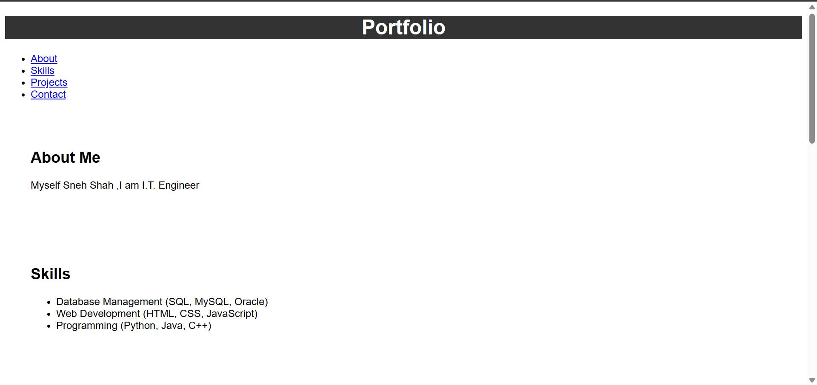

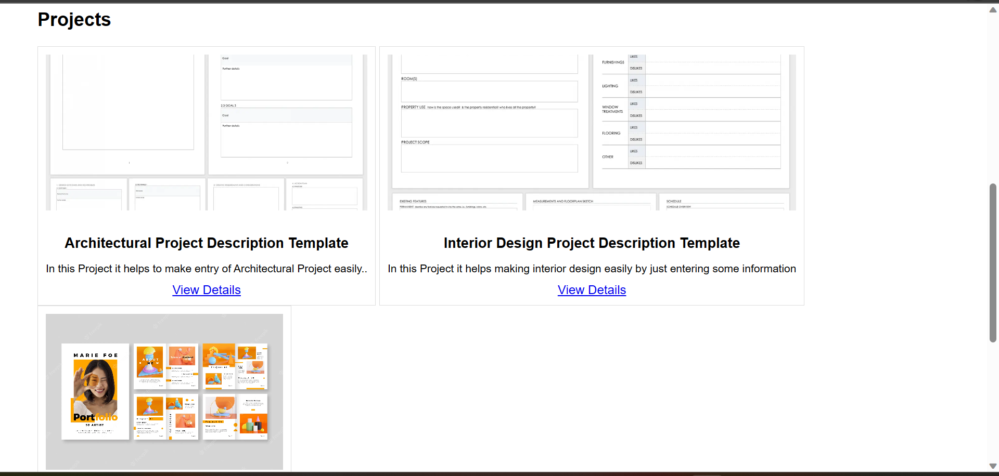

AIM:**2) Create a webpage that serves as an "About Me" page with the following components:**

**A heading that displays your name or the title "About Me"**

**A paragraph introducing yourself, including your background, interests, and any notable achievements or experiences you'd like to highlight.**

**A section with a bulleted list of your skills or areas of expertise.**

**Include a section with an image of yourself.**

**Create a table with two columns: one for your education history (include institution name, degree, and graduation year) and another for your work experience (include company name, position, and employment dates).**

**Add a contact section with fields for name, email, and a message.**

**HTML CODE:**

**<!DOCTYPE html>**

**<html lang="en">**

**<head>**

**<meta charset="UTF-8">**

**<meta name="viewport" content="width=device-width, initial-scale=1.0">**

**<title>My Favorite Movies</title>**

**<link rel="stylesheet" href="./Style1.css">**

**</head>**

**<body>**

**<header>**

**<h1>My Favorite Movies</h1>**

**</header>**

**<ul>**

**<li>PHIR HERA PHERI</li>**

**<li>MS DHONI:THE UNTOLD STORY </li>**

**<li>LOVE NI BHAVAI</li>**

**</ul>**

**<img src="https://m.media-amazon.com/images/M/MV5BZjAzZjZiMmQtMDZmOC00NjVmLTkyNTItOGI2Mzg4NTBhZTA1XkEyXkFqcGdeQXVyODE5NzE3OTE@._V1_.jpg" alt="Movie Poster">**

**<p>**

**<a href="https://www.hotstar.com/in/movies/ms-dhoni-the-untold-story/1000164358/watch" target="_blank">Official Website</a> of one of the movies.**

**</p>**

**</body>**

**</html>**

**CSS CODE:**

**body {**

**font-family: Arial, sans-serif;**

**background-color: rgb(205, 205, 50);**

**}**

**header {**

**background-color: #333;**

**color: #fff;**

**padding: 20px;**

**text-align: center;**

**}**

**h1 {**

**font-size: 24px;**

**}**

**ul {**

**list-style-type: disc;**

**}**

**img {**

**max-width: 300px;**

**display: block;**

**margin: 20px auto;**

**}**

**a {**

**text-decoration: none;**

**color: #333;**

**font-weight: bold;**

**}**

**OUTPUT:**



